**PYTHON LABORATORY**

**Exercise No:1**

**Date:14/10/2020**

**Aim:**

To Write a Python function countX(lst, x) to count the number x in a given list of numbers.

**Program:**

import calendar as cal

y=int(input())

m=int(input())

if(y>999 and y<10000):

if(m>0 and m<13):

print(cal.month(y,m))

else:

print("Invalid input")

else:

print("Invalid Input")

**Link:**

<http://103.53.53.18/mod/vpl/forms/edit.php?id=229&userid=1708#>

**Output:**

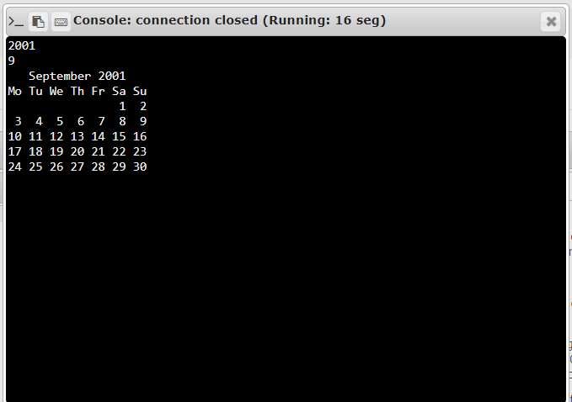

**Result:**

The Python program to print the calendar of a given month and year is executed.